

COLLEGE of INFORMATICS and ELECTRONICS

Department of Computer Science
and Information Systems

End-of-Semester Assessment Paper

Academic Year: | 03/04 | Semester: | Summer
Module Title: | Computer Networks | Module Code: | CS4225
Duration of Exam: | 2½ Hours | Percent of Total Marks: | 100
Lecturer(s): | Dr Séamus O’Shea

Instructions to Candidates:
Answer any 3 questions. Questions are equally weighted.

1. (a) Explain how an analog signal can be modulated to carry binary data. (11 marks)
(b) The following diagram shows a modulated analog signal. Describe the type of modulation in use in this example, and draw the corresponding constellation diagram. (10 marks)

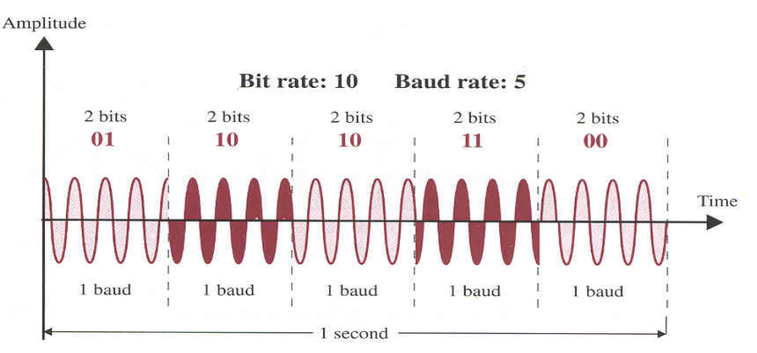

(c) Draw a diagram to show the structure of an Ethernet frame. What is the maximum payload size? In the case of received frame, how does the Ethernet protocol decide which higher layer protocol should receive the frame’s payload ? (12 marks)

2.(a) Define the decibel unit of signal intensity measurement. What are the attractions of expressing intensity losses/gains in decibels? Prove that the decibel scale is linear with distance. If the loss experienced by a signal in travelling over a communication line is (i) 3dB (ii) 10dB, what fraction of the original signal strength does this loss represent in both cases? (11 marks)
(b) State some of the most desirable properties of a line code. Describe, via a diagram, the line code used in Ethernet. What are the attractions of this line code? Draw a diagram to show the AMI line coding scheme and describe its advantages and disadvantages. Give an example of a line code that conveys (i ) 2 bits per baud (ii) ½ a bit per baud. (11 marks)
(c) Explain what the purpose of a modulator is in the context of data communications. Using phase modulation, show, via a diagram, how a bit rate of 28.8 kbps may be achieved using a baud rate of 9600. (11 marks)

3. (a) Discuss the benefits attaching to CIDR in the context of IP address allocation. (8 marks)
(b) A network interface on a user’s PC is allocated the IP address 192.168.4.17 with a corresponding mask of 255.255.255.240. How many bits does the hostid part of the address contain? (8 marks)
(c) How many bits are in the hostid part of the address block 132.45.96.0/19 ? (8 marks)
(d) The user’s PC has a default Gateway configuration of 192.168.4.45. The PC user pings the interface 192.168.8.11. Explain the results. (10 marks)

4.(a) Describe the main features of connection oriented and connection less communication. Does the IP layer on a host machine ensure that packets, received over the network, are in the right order before presenting them to the transport layer? (10 marks)
(b) The Internet can be described as a collection of subnets interconnected via IP routers. Describe the process by which IP routers co-operate to deliver packets over the various subnets to their eventual destination(s). What kind of information is typically held in the routing tables of Routers? How do Routers keep this information up to date? (11 marks)
(c) Briefly describe the purpose of the RIP and OSPF protocols within IP routed networks. What communication mode do those protocols use? In the case of sparse and sporadic traffic between Remote Routers, dial up lines are often used, over which the SLIP or PPP protocols are used. Describe the main features of these protocols. (12 marks)

5.(a) Compare the tasks performed at both the link layer and transport layers in a typical protocol stack. Suppose the path from source to destination involves a single router. If the router discards a packet because of congestion, will the checksum mechanism at the link level at the destination indicate this error ? (11 marks)
(b) Consider the HDLC link protocol and the TCP transport layer protocols. Compare the flow control mechanisms available to each protocol. If TCP at the destination node discovers that a segment is missing, describe how it reacts. (11 marks)
(c) Discuss the advantages and disadvantages of both static and dynamic routing strategies. Give an example of how a static route could be set up. How would you check the route taken by a packet from source to destination? (11 marks)

